NOVEMBER-DECEMBER 2013
RUN 06-2013
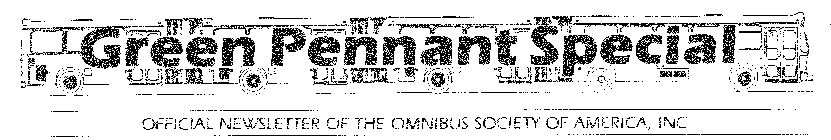
Welcome to another issue of The Green Pennant Special, the official publication of The Omnibus Society of America.
Through this publication we hope to keep our readers informed of events happening in the transit industry in Chicago and other cities in the United States.
Visit the Omnibus Society of America website at osabus.org. At osabus.org we will be posting upcoming fan trips and meetings information, as well as membership information.
Please visit our site when you have a chance and give us your opinions and comments.
- NOV/DEC MEETINGS
The November meeting of the Omnibus Society of America will be held on November 1, 2013, in the Anderson Pavilion of Swedish Covenant Hospital. The meeting will start at 7:30 pm.
Our program will be a “Potpourri” presented by Mike Mullenback.
The December meeting of the Omnibus Society of America will be held on December 6, 2013, in the Anderson Pavilion of Swedish Covenant Hospital. The meeting will start at 7:30 pm.
Our program for the evening will be a presentation by long-time member Ed Montajano on the current Milwaukee transit scene.
ELECTION NOTICE
The director’s positions of John LeBeau and Verne Rosenthal are up for election in December. There will be a call for nominations at the November meeting, with ballots being mailed out the second week of December.
Mayor Emanuel Breaks Ground for Cermak Avenue Green Line Station
8/29/2013
New Station Near McCormick Place Part of $92 Million in CTA Station Developments that will Foster Economic Growth Throughout the Near South Side
Mayor Rahm Emanuel and local officials broke ground today on the new Cermak Green Line station, a $50 million construction project that will energize the area around McCormick Place and provide a crucial additional transportation option for the Near South Side. The $50 million station is part of $92 million in overall transportation
investments, including the rehabilitation of the Roosevelt and Harrison stations on the Red Line and the 18th Street Connector, which will significantly revitalize the near south side of the city.
“We are making a comprehensive investment in the CTA, and this investment includes building a new station to serve McCormick Place and the surrounding area,” said Mayor Rahm Emanuel. “We are improving our infrastructure to brighten our economic future. You cannot have a 21st century economy sitting on a 20th century economic infrastructure.”
The 18th Street Connector, which carries Orange Lines trains to and from the Loop, is undergoing $25 million in renovations, and the Harrison street station ($10 million), and on Roosevelt Road ($7 million) are also being improved, to bring to a total of $92 million in new investment to the area. Billions of dollars are currently being put toward transit improvements throughout the city of Chicago, which will reshape the infrastructure of the city for decades to come.
“The new Cermak-McCormick Place station will offer a convenient transit option for commuters, residents, employees and visitors, and at the same time help support economic development well under way in the community,” said CTA President Forrest Claypool.
The future Green Line station at Cermak will be the first station at that location since 1977. This new station fills in a major gap in CTA service that has existed at McCormick Place since the station was demolished. It is part of $4 billion in investments ongoing in the CTA system alone.
The Cermak station will be the 146th CTA station. The construction project is being managed by the Chicago Department of Transportation, and is expected to be completed by the end of 2014. The station will be located near the intersection of Cermak Avenue and State Street and directly west of the McCormick Place convention center. The new station will be located in the two-mile stretch between the existing Roosevelt and 35th-Bronzeville-IIT Green Line stations and will provide much needed access to rapid transit for neighborhood residents and businesses, including McCormick Place.
The Cermak-McCormick station, which is financed with $50 million in Tax Increment Financing (TIF) funds, will include three entrance points – one on each side of Cermak Road and one at 23rd Street. The main station building will be built on on the north side of Cermak road, equipped with modern amenities such as elevators, bike racks, state-of-the-art security, and enclosed boarding platforms.
CTA Moves to Next Steps of Major Upgrade of ‘Ravenswood Connector’ for Brown, Purple Lines to Increase Track Speeds and Improve Service Reliability
9/6/2013
Major work on $71.2M rehabilitation project begins Sunday and will eliminate 70 percent of Brown Line slow zones
The Chicago Transit Authority today announced the start of major construction work on the $71.2 million Ravenswood Connector rehabilitation project. This project will eliminate more than 70 percent of Brown Line slow zones and will result in safer, more reliable service on a key segment of the Brown and Purple Lines between Armitage Avenue and the Loop.
Beginning Sunday, September 8, CTA ironworkers will begin major project work following months of preliminary preparation on the Connector project. The upcoming work will include the repair and replacement of components on the steel structure between the Armitage and Merchandise Mart elevated stations. Preliminary project work began this summer with crews taking measurements and fabricating replacement infrastructure components.
The elevated infrastructure between Armitage and the Loop was originally constructed in the late 1800s. Once the infrastructure work is completed, the CTA will begin replacing deteriorated rail ties and track components, work that is expected to begin in 2014.
“The CTA’s investment in the Brown and Purple Line tracks will provide faster and more reliable service to the nearly 40,000 customers who take Brown and Purple Line trains into the Loop each weekday,” said CTA President Forrest Claypool. “The Ravenswood Connector’s condition has resulted in numerous ‘slow zones’ that require trains to operate at maximum speeds of 15 m.p.h. This project will not only improve the safety and reliability for the 700 trains that travel to and from the Loop each weekday, it will eliminate more than two miles worth of slow zones.”
To minimize the impact to service, structural repair work will be performed mostly late at night and on weekends. During these times, trains traveling in both directions will operate on a single track, which will result in longer travel times and occasionally changes in boarding locations at rail stations. Additional information regarding any scheduled impacts to service will be made available each week on the CTA website under “System Status & Alerts.”
CTA Announces #111A Pullman Bus Shuttle Service
9/10/2013
The Chicago Transit Authority today announced it will expand bus service in the Pullman neighborhood tomorrow in conjunction with the opening of a new Walmart store at 10900 S. Doty Avenue.
The CTA will offer the #111A Pullman bus shuttle every 20 minutes on weekdays between 10 a.m. and 2 p.m., and 4:30 p.m. to 7:30 p.m., and on weekends and holidays between 10 a.m. and 4 p.m. to accommodate ridership during periods when demand is expected to be highest. This service will remain while a final service plan is reached with the developer and community.
“The CTA is pleased to be able to offer additional bus service in this growing community and serve patrons, workers and residents in the neighborhood,” said CTA President Forrest Claypool. “This service has been put in place as we continue to develop a final service plan with the developer and the community.”
"I am pleased that we have reached a solution for residents, the community, and workers at the newly opened Pullman Park Walmart development," said Alderman Anthony Beale. "I appreciate the willingness of Forrest Claypool and the Chicago Transit Authority to reach an agreement that will make the opening of this store the best it can be."
From 111thStreet/King Drive, #111A buses (to Pullman Park) will operate south on King Drive to 113th Street, then will travel via 115th Street (due to construction reroute), Cottage Grove, 111th Street, Doty to 109th where they will then enter the Pullman Park via private roads and loop around the parking lot and CTA access road. Return trip #111A buses (to 111th/King Drive) will travel to Doty Avenue and travel the reverse route. The route will make connections with the 111th and 115th street bus routes.
CTA Board Approves Agreement to Continue #128 Soldier Field Express Service
9/11/2013
Renegotiated agreement with Metra means quick, affordable round-trip service on game days
The Chicago Transit Board today approved a new agreement with Metra to continue non-stop bus service from two Metra rail stations in the West Loop to Chicago Bears’ games at Soldier Field – a service the CTA has been provided since 1988.
Under the new three-year agreement, Metra has agreed to fully cover CTA’s operating costs minus fare revenue, for the operation of the #128 Soldier Field Express route. The cost of the round trip is $5 for adults and $2.50 for reduced-fare customers. The new agreement is retroactive to August 15, 2013 and extends through August 15, 2016.
The Soldier Field Express operates non-stop between the Ogilvie Transportation Center, Union Station and Soldier Field on Chicago Bears home game days.
“Sports fans appreciate tradition, and for the past 25 years we have been providing Chicago Bears fans with a convenient travel option to get them to and from Soldier Field,” said CTA President Forrest Claypool. “We are pleased that we are able to continue our partnership with Metra to offer fans quick, affordable transportation to games.”
The renegotiation of this agreement was a component of CTA’s Crowding Reduction Plan, which was implemented in December 2012 to add rail and bus service to high-demand routes. The Plan included renegotiating specialized contracted routes that were being subsidized by CTA.
New CTA campaign emphasizes rail-customer safety
9/16/2013
“It’s Not Worth Your Life” messages highlight dangers of being on tracks
As part of its continuing focus on customer safety, the Chicago Transit Authority has launched a new informational campaign reminding ‘L’ riders about the dangers of trespassing on CTA railroad tracks.
The campaign, featuring the tagline “Stay Off the Tracks, It’s Not Worth Your Life,” features a series of messages highlighting the dangers of activities such as trying to retrieve items dropped onto the tracks, standing too close to the edge of a platform, or trespassing along the railroad right of way.
“Safety has always been and will always be our No. 1 priority, in every facet of our operations,” said CTA President Forrest Claypool. “We created the campaign as an important reminder to our customers, and we believe it will help further promote safe behavior on our rail system.”
The CTA has long had a very strong safety record related to rail service. In 2012, the CTA provided just over 230 million rail rides, with 11 fatalities reported resulting from customers on the tracks. In 2011, there were 221 million rail riders and nine fatalities. Since 2009, there have been between six and 12 rail-related fatalities annually, many of which involve intentional acts by customers.
“Though the number of fatal incidents on the CTA is extremely low, one incident is one too many,” Claypool said. “We continue to work to ensure the safest system possible, and to both remind and encourage our customers to take simple steps to keep themselves safe.”
Customers who enter CTA tracks, known as the rail right of way, face not only the danger of oncoming trains, but also that of the third rail, which carries 600 volts of electricity used to propel trains—a level of electricity that is almost always lethal.
In 2012, CTA received more than 300 reports of customers entering the right of way, ranging from riders jumping off a platform to pick up a dropped mobile phone to trespassers walking on tracks between stations. The vast majority involve people making a conscious decision to go on the tracks, officials said. Alcohol has been a factor in many incidents, according to both CTA and Chicago Police records. Very few of those reported incidents involve customers accidentally falling or tripping onto the tracks.
Anyone caught trespassing on the right of way will be prosecuted to the fullest extent of the law, CTA officials said. Unfortunately, very few arrests are made each year, because most individuals leave the right of way shortly after they enter, CTA officials said.
“No customer should ever enter the rail right of way, for any reason,” said Araceli De La Cruz, CTA’s Chief Safety and Security Officer. A customer who drops an item can inform a CTA station employee, all of whom have received proper safety training and can communicate with CTA’s Control Center to slow or stop trains or remove power as needed.
This latest campaign complements CTA’s existing rail safety information, including signs along the tracks, at every rail station and in every rail car, as well as safety brochures, website information and other materials. “This campaign will expand and reinforce the important safety messages we provide our customers every day,” Claypool said.
The new safety campaign’s car cards and posters will appear on rail cars and at rail stations throughout the CTA system starting this week, and will also be used on digital signs at stations.
More information is available at www.transitchicago.com/safety/
CTA and Artist Theaster Gates to Host Five Community Meetings for the Historic 95th Street Terminal Art Project
10/8/2013
As part of the 95th Street Terminal Improvement project, the Chicago Transit Authority (CTA) has tapped internationally recognized Chicago-based artist Theaster Gates to create the largest public art project in the agency’s history. As part of that effort, the CTA and Mr. Gates will host a series of meetings to discuss the historic artwork plan with members of the communities near the 95th Red Line terminal.
Working with the CTA, Mr. Gates has created a unique, catalyst program that will foster community engagement, provide jobs and offer training to art students. The two original artworks to be created under this initiative will be permanently displayed at the new 95th Street Terminal, construction for which will begin next year.
The artwork envisioned for the 95th Street terminal include an architectural feature integrated into the terminal building structure, and an independent artwork for the terminal or one of its walkways.
Local residents are invited to attend the following meetings, which are part of the artist’s goal to engage and promote dialogue among community residents, architects and designers.
The estimated $240 million construction project will expand and greatly improve the 95th Street Terminal, which is one of CTA’s busiest rail stations and a vital anchor and gateway to Chicago’s South Side. The new 95th Street Terminal will be a showcase station of the CTA and the premier multimodal transportation terminal in the region. This artwork—and the community-driven process that will create it—will be a strong complement to the new terminal.
Construction of the new terminal, funded by local, state and federal dollars, is expected to begin in 2014, after completion of the Red Line South reconstruction. The terminal project is expected to be completed in 2016.
Information about this project is also available at www.transitchicago.com/95thTerminal/.
CTA Adopts Western Extension to #35 Bus Route, Adds New Beach Service
10/9/2013
Service enhancements made permanent following year-long analysis
The Chicago Transit Board today approved a plan to begin permanently offering bus service on the west end of the #35 31st/35th bus route after a year-long service trial, and the addition of new service on that route to the 31st Street Beach during the summer months. These changes in service will improve public transit options and connections for customers on the city’s South and Southwest sides.
“We’re pleased to be able to make these route changes permanent for the benefit of CTA customers by providing greater access to work, businesses and Chicago’s lakefront parks and beaches,” said CTA President Forrest Claypool. “In addition, customers now have additional transit travel options requiring fewer connecting trips, which results in improved travel times.”
Since September 2012, the CTA has been operating experimental service that included extending service on the #35 route west along 31st Street between Kedzie and Cicero avenues. This experimental service was implemented based on increased potential ridership demand in the corridor and the improved connections it would create for customers to access CTA’s Red, Green and Orange lines; other CTA or Pace bus routes; and Metra’s Cicero station.
Service along the route extension will continue to be provided seven days a week, between the hours of 5 a.m. to 8 p.m. and at a frequency of 10-20 minutes, depending on the time of day. Hours of service along the #35 route east of Kedzie will remain the same, from approximately 4 a.m. until 12:30 a.m. seven days a week.
The Board originally approved offering trial service last fall for six months and in April extended the experimental service another six months to allow the CTA more time to study ridership trends on the route before making the route extension permanent. As part of that April decision, the CTA also said it would study the feasibility of extending service east to the lakefront at 31st Street.
Based on a comprehensive study of census and ridership data, the CTA determined there was not enough demand to support a new route on 31st Street east of Ashland and Archer, but the CTA will provide new weekend and holiday bus service to the 31st Street Beach via the #35 bus route beginning next summer between Memorial Day and Labor Day. Select #35 buses will operate to the beach and hours of beach service will be approximately 9:00 a.m. to 9:30 p.m. on weekends and holidays.
Federal funds from a Job Access Reverse Commute (JARC) grant will be used to help support operational costs of the route extension, which is estimated to cost approximately $1.2 million annually. The extension of service to the 31st Street Beach will be approximately $24,000 annually
CTA Moves Forward With Red Line 95th Street Terminal Project
10/9/2013
Agency hires construction manager/general contractor to oversee $240 million project, to begin in 2014 and better serve Red Line, bus customers on the South Side
The Chicago Transit Authority has hired a construction manager for the new Red Line 95th Street Terminal at 95th Street/Dan Ryan station, through a process designed to help ensure timely, efficient completion of the project and promote strong participation from Disadvantaged Business Enterprise contractors.
The $240 million project will expand and greatly improve the 95th/Dan Ryan Terminal and bring significant improvements to a bus and rail station that is a vital part of the South Side and serves about 20,000 customers each weekday.
The Chicago Transit Board today approved awarding the contract to Walsh/II in One J.V., which will serve as Construction Manager/General Contractor at Risk (CM/GC). Through this arrangement, a construction manager for the entire project is selected to begin work during the design phase of the project, rather than the typical practice of hiring a general contractor after the design of the project is completed.
The benefits include reducing the chances of project delays and cost overruns in complex, heavy civil construction projects like the 95th Street Terminal, because the CM/GC is involved in aspects of the project including resolving complicated constructability issues, materials selection and other critical logistics. It also advances the start of the project’s construction by about five months. This form of procurement is being used for other Chicago projects including the McCormick Place West Expansion and the new Rental Car Facility at O’Hare International Airport. The same approach has been used by other U.S. transit agencies for large-scale projects, including in Boston, Dallas and Portland.
The value of the contract is not to exceed $648,000. The award include 30 percent Disadvantaged Business Enterprise (DBE) participation, including II in One Contractors, Inc. (20%), which will serve as a project principal, chief estimator, and estimating and DBE compliance officer for preconstruction services, and The Roderick Group, Inc. (10%), which will provide design validation reviews. Other contracting tasks include cost estimating, 3-D modeling, determining site staging/logistics and other project tasks.
The 95th/Dan Ryan Terminal is one of CTA’s busiest, with 24-hour Red Line service and over 1,000 CTA and Pace bus trips on a typical weekday. The current configuration does not have adequate capacity to efficiently serve customers, which number around 20,000 on an average weekday. Construction on the new 95th Street Terminal will begin in the spring of 2014 and is expected to be completed by the end of 2016. Funding is provided through a variety of federal, state and local sources.
The current 95th Street Terminal will remain open during the project. The rail station portion of the terminal is scheduled to reopen on Sunday, October 20, when the Red Line South branch is reopened following a five-month $425 million project that rebuilt the 10-mile stretch into a brand-new railroad. The new Red Line South, built on time and on budget, is expected to reduce round-trip commutes by as much as 20 minutes each day.
33 Injured After 2 Chicago Transit Authority Trains Collide
More than 30 people were injured Monday morning after two trains running on the Chicago Transit Authority’s Blue Line tracks collided, CTA officials confirmed.
The accident happened just before 8 a.m. at Harlem Avenue and Interstate 290 in suburban Forest Park. A westbound train that stopped at the Harlem station was struck by an out-of-service train heading toward the Loop, officials said.
CTA officials said 33 people were transported to nine area hospitals. Forest Park Mayor Anthony Calderone told reporters most of the transported riders complained of neck or back pain.
Police initially treated the area as a crime scene because the out-of-service train may have been stolen, sources said, but the CTA disputed the train was taken without authorization. The National Transportation Safety Board has since taken over the investigation.
"We're exploring everything," an NTSB spokesman said. "We want to establish that the signal system worked, that's the first thing you want to rule out. Then you want to rule out mechanical issues ... then you look at operations."
Robert Kelly, of Amalgamated Transit Union 308, said it's still unclear what happened and how the train got out of the station.
"Both the supervisor in the station at Forest Park and the motorman who was sitting in the station said there was nobody on the train as it went through and collided with the other train," Kelly said.
"This is baffling everybody," he said.
CTA spokesman Brian Steele said there are more questions than answers as staff reviews surveillance video and talks to employees.
"We don't know what the circumstances are that led to this train to begin moving on the path that it did," Steele said. "It shouldn't have done so and the question of why is what we're looking into."
Blue Line service between Forest Park and Austin was suspended after the incident, and shuttle buses were in place.
NBC 5 Investigates has learned that the train began its journey at the CTA's Forest Park yard, where it had been parked and awaiting service since Sept. 23.
By the time it traveled the short distance to the Forest Park station on Monday morning, eyewitnesses said they saw nobody in the motorman's cab.
It's believed to have continued on, unmanned for about half of a mile to the spot where it collided with the other train car.
"That train never should have made it to the Forest Park station. It should have been tripped in the yard," Kelly said.
Someone had to start the train, and even if they bailed out, it had to travel up an incline and pass through three different fail safe systems designed to stop it. The last fail safe is located in the cab itself, designed to alert a motorman of impending danger ahead.
"It's a red indication in the cab, when you are approaching something, another train or object, a broken rail, that goes off," Kelly said. "The motorman has to go brake within seconds. If they don't go to brake, the automatic train control will cut them off, and the train is supposed to come to a stop."
All El trains work from a common key, and sources tell NBC 5 Investigates that there are a lot of train keys out there unaccounted for.
It could explain how the train was started, but not how it was able to travel across so many safeguards designed to stop it without someone aboard.
It's also unclear why no one in the CTA command center saw the disaster coming.
"We have people working in these yars all over the system, and if we have trains that can start moving on their own, our people are in danger out there," Kelly said.
Witnesses said at least one person was taken away on a stretcher, but the CTA tweeted the injuries were "minor."
Loyola University Medical Center confirmed they received four patients from the collision but said their injuries were "not serious."
"I went forward and caught the rail," one passenger said. "I jammed my hip, my feet and my leg."
Westlake Hospital in Melrose Park said they were treating two patients in good condition and West Suburban Medical Center in Oak Park reported they received one patient in good condition.
Martinez Butler, a locomotive engineer for another train company, was standing at the corner when the trains collided.
"There was a train that was stopped at the station. Another train came through and looked like it blew the signal, because I heard beeping," she said. "I'm a locomotive engineer. I know the systems, I know the sounds. When you hear that beeping it's warning you that there is an obstruction in front of you and you need to stop." www.NBCChicago.com
City releases final renderings of Washington-Wabash CTA station
Mayor Rahm Emanuel, CTA and CDOT officials today released the final renderings for the planned Washington-Wabash Elevated CTA Station, which will be constructed between Madison and Washington. The station is designed to become a gateway for Millennium Park and the Loop, as well as transform the public’s perception and expectation of public transportation in Chicago.
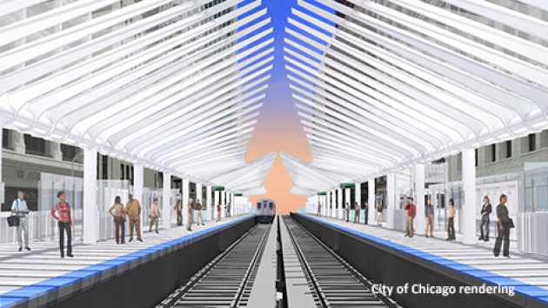
"This station features a modern design with undulating waves that serve as a welcome contrast to the city grid and will replace two century-old stations that were not designed for the needs of modern public transit," said Mayor Rahm Emanuel. "You cannot have a 21st century economy sitting on 20th century economic infrastructure and we continue to make investments throughout the entire CTA system to improve our infrastructure and brighten our economic future."
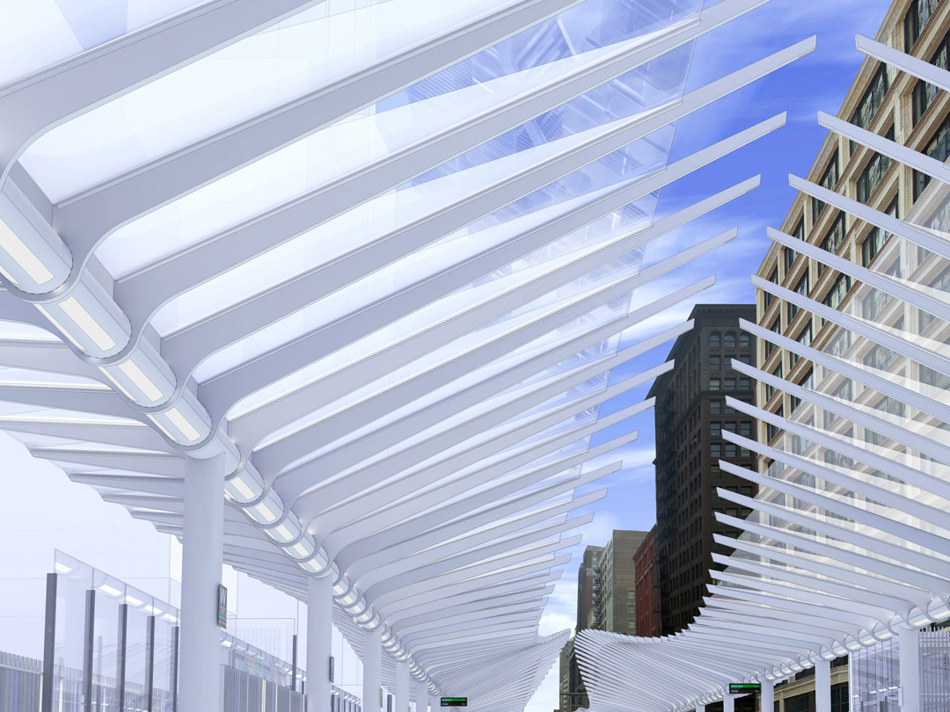
The undulating wave form of the canopies weaves through the historic Wabash Avenue corridor as a counterpoint to the city grid, and anticipates the soft forms of the park and the lake beyond. The faceted skeletal steel and glass structure is designed to create a dynamic play of light reminiscent of diamond facets and the historic Jeweler’s Row.
Materials have been chosen to allow visibility, reinforce the feeling of openness and to allow a visual connection to the historical corridor. The vibrant new facility will enhance passenger convenience, improve train speeds, decrease operating costs and provide accessibility for all riders.
"The new Washington-Wabash station will serve as a convenient option for the tens of thousands of transit riders who travel to the Loop for work or visit the many destinations downtown, including Millennium Park,” said CTA President Forrest Claypool. “This is a crucial investment that will pay dividends for many years, as the new station will offer improved amenities and larger platforms for all riders."
Construction of the $75 million station is expected to begin in the fall of 2014 and the station is scheduled to open in 2016. According to recent estimates from CTA, the Washington-Wabash station is expected to have 13,375 daily entries (annual weekday average), making it the 5th busiest CTA station on weekdays. The annual total for the station will be 4.02 million rides.
The station will be funded entirely by Congestion Mitigation and Air Quality (CMAQ) funds.
"With the unveiling of this design, tens of thousands of Chicagoans who take the El downtown every day can look forward to less congestion and a cleaner, greener, state-of-the-art platform,” Senator Dick Durbin (D-IL) said. “Modernizing our nation’s mass transit systems is crucial for future growth, which is why I have worked to establish new federal investment opportunities specifically for projects like the Chicago Transit Authority’s efforts to upgrade and renovate. I am glad that the CTA has recognized the value of these projects and is working to make these crucial improvements throughout its system as resources allow."
"Modernizing our transit infrastructure is a key component of maintaining Chicago's status as an economic engine and tourism hub," said Senator Mark Kirk (R-Ill). "I support the efforts of Mayor Emanuel and CTA President Claypool to ensure our stations continue to meet future demand."
Congressman Danny K. Davis (IL-07) stated, "I am excited for the unveiling of the new design plans for the Washington-Wabash station. The new design will add a modern component for the El. I applaud Mayor Emmanuel and President Claypool and look forward to completion."
The Chicago Department of Transporation is managing the design and construction of the station, which is the first to be built in the loop was the Library/State-Van Buren station in June, 1997.
The station was designed by Teng + Associates, now known as exp, an integrated architecture and engineering firm recognized for design excellence in architecture and engineering for an array of projects in both the public and private realm.
The fare controls, stairs, escalators, elevators, electrical, security and communications rooms will be on the mezzanine level. The station will be entirely new and will meet ADA standards with new elevators from the street to mezzanine and platform levels. The platform capacity will be enlarged from the existing 7’-6” width to 10’ to 13’ widths.
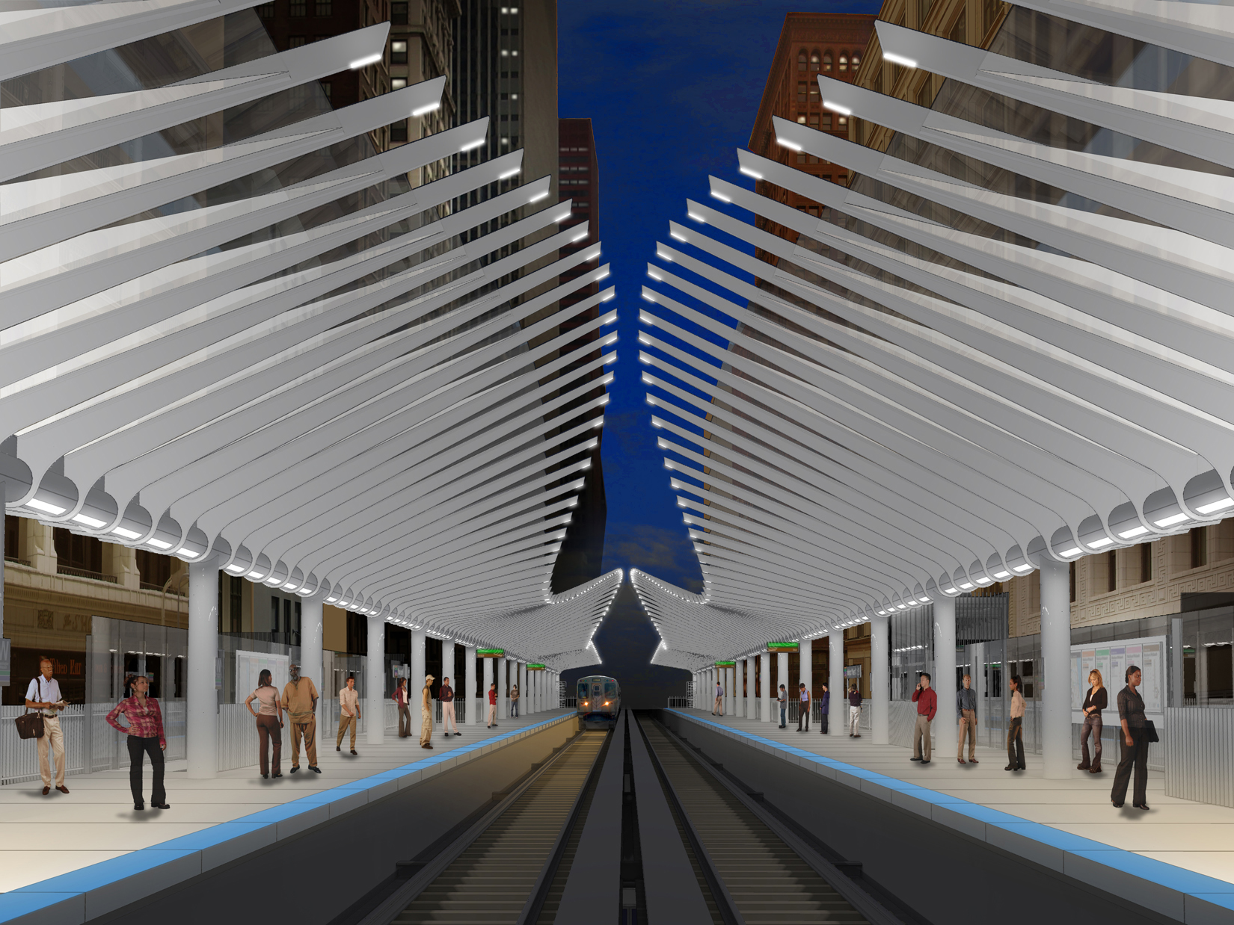
The station will feature a wide array of green and sustainable elements, including:
- 100 percent LED lighting.
- The project will reuse a significant amount of existing structure and tracks.
- Bicycle racks will be installed to encourage alternative transportation.
- Recycling bins will be installed on the platforms to encourage paper recycling.
- Concrete Masonry Units used in wall assemblies will be from regional sources.
- Structural steel will be comprised of recycled material, and metal fabrications used for cladding, wall infill panels, windbreaks, handrails and other items will be comprised of recycled content.
- Rough carpentry required for blocking will be comprised of Certified wood.
- Sealants and adhesives, exterior paint for the structural steel and interior paint for CTA offices will have a low-VOC content to improve air quality
- HVAC systems used for the Customer Assistant and Concessions kiosks will use CFC-free refrigerant.
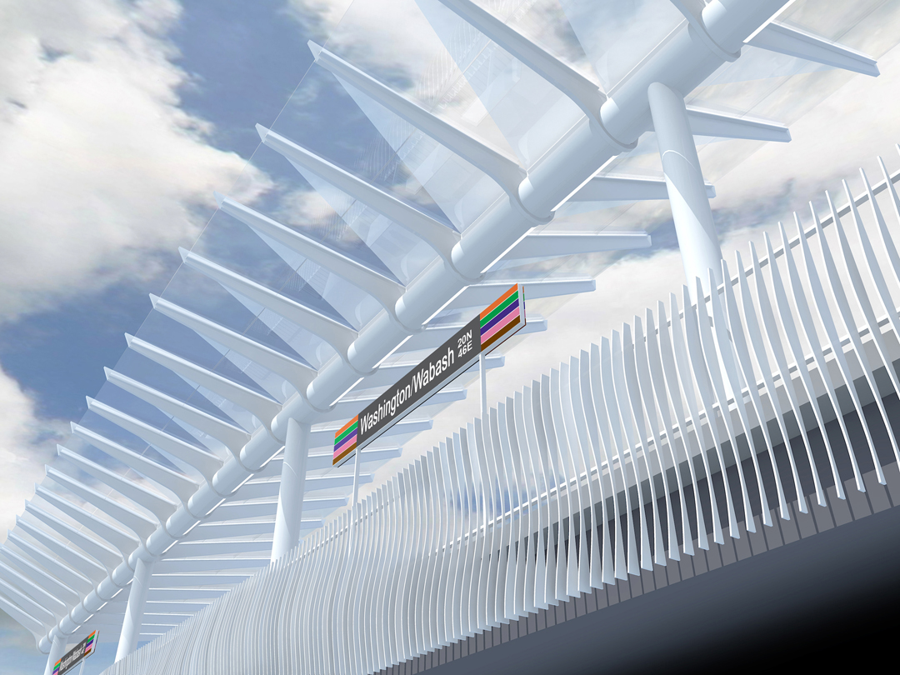
89 WLS
CTA President Releases 2014 Budget Recommendations
10/18/2013
Proposed balanced budget maintains current fares and service levels, reflects third straight year of balanced budgets for agency; spending plan continues historic investment in modernization
Chicago Transit Authority President Forrest Claypool today proposed a balanced $1.38 billion budget that maintains transit service and holds the line on customer fares, while continuing unprecedented investment in projects and programs to improve service and modernize regional transit.
The budget reflects the positive impacts of operational efficiency reforms by CTA management to reduce wasteful spending and manage day-to-day operations more efficiently. The budget also includes the 1,000 customer-facing jobs the CTA created in 2013 to better serve passengers.
“I congratulate Forrest Claypool and the team at CTA for presenting another balanced budget,” said Mayor Emanuel. “The CTA staff has worked hard to provide outstanding service for its customers in the most efficient fashion possible. Chicago’s public transportation system is world-class and helps millions of residents get to work and school each week.”
The agency in 2014 will continue its ambitious $4 billion capital investment plan begun in 2011, including rehabilitating rail stations, modernizing rail and bus fleets, and bringing the agency’s massive infrastructure into a state of good repair to improve reliability and safety.
“The CTA has operated efficiently and responsibly with three straight years of balanced budgets after inheriting a $308 million deficit in 2011,” said CTA President Forrest Claypool. “We’ve done so through rigorous management reforms that have reduced waste and trimmed spending, while upholding service and fare levels for our customers and creating permanent jobs that better serve passengers. Our new collective bargaining agreement with CTA labor unions has also contributed significantly to the financial turnaround, allowing us to reduce costs while also adding good service-providing jobs for union members.”
The CTA continues its strong financial performance despite the negative effects of state budget cuts and higher unfunded state mandates for everything from health care and pension costs to free and discounted rides.
The budget reflects management reforms previously put into place, including modernizing supply chain operations to better track purchases and inventory and achieve lowest-cost pricing. It also includes progress in lowering absenteeism, which has declined in 2012 and 2013 and is estimated to save the agency $10 million a year.
The CTA is continuing its historic level of investment in its bus and rail systems under the leadership of Mayor Emanuel and follows the CTA’s successful delivery of a brand new Red Line South railroad in 2013 on time and on budget that will benefit 80,000 daily Red Line South commuters.
Next year the CTA will begin construction of a new 95th Street Terminal, a $240 million project that will expand and upgrade the 95th/Dan Ryan station, connecting Far South Side communities to job centers throughout the region and serving as a transit gateway for the South Side and suburbs.
Work will also begin on the reconstruction of the Wilson Red Line station into a modern Red-Purple transfer station, as well as on the Green Line at Cermak -- all projects that benefit customers and will boost local economic development in Chicago’s neighborhoods.
Also in 2014, the CTA will continue its $71.2 million Ravenswood Connector project to upgrade track and related rail structure between the Chicago and Armitage stations on the elevated Brown and Purple Express lines.
The CTA also will continue a major plan to replacing or overhauling its bus and rail fleets to increase reliability and comfort for our customers, including taking delivery of and procuring new rail cars as well as obtaining new buses this year. These investments lower future operational costs for the agency and provide more comfortable, reliable commutes for CTA customers.
The CTA places a high priority on safety and security by leveraging technology to maximize the agency’s efforts, including the installation more than 3,600 cameras across the entire rail system, more than 5,000 cameras on rail cars and as many as 10 cameras on each of our 1,800 buses. Working closely with the Chicago Police Department’s Public Transportation Unit, cameras assisted in at least 140 arrests in 2013 and are key in our efforts to combat crime and create a more secure environment for our customers.
The agency continues its commitment to upgrading technology across its system, including a plan to upgrade wireless communications in its subway tunnels and added electronic screens displaying CTA’s Train Tracker service at every rail station in 2013. The CTA’s new fare-payment system, Ventra, will also be fully rolled out by the end of 2013, providing customers with a modern fare-payment system and reducing the agency’s operational costs of maintaining an obsolete fare-payment system.
Total ridership on the CTA is expected to grow in 2014 from this year to 534.6 million (a jump of nearly 1 percent), returning to slightly above 2011 levels.
A public hearing will be held on Tuesday, November 12, 2013 at 6 p.m. at CTA headquarters, 567 W. Lake Street, second floor conference room, Chicago, Illinois, 60661.
Late Night Closure of Three Secondary Station Entrances
10/18/2013
Beginning Sunday, October 20, the secondary entrances at the following three rail stations will be closed during the late night hours each day when ridership is at its lowest and the entrances are least utilized:
- Jackson Blue Line: from 1:30 a.m. until 4:30 a.m. each day, the auxiliary entrances to the Jackson Blue Line station, which are ½ a block north of Van Buren, will be closed. Customers will be directed to use the accessible Adams Street station entrance, which is one block north on Dearborn adjacent to the Dirksen Federal Court House.
- Washington Blue Line: customers will be directed to use the Randolph Street entrance to the Washington Blue Line station beginning at 11 p.m. each night. The Madison Street auxiliary entrance will re-open the following morning at 6 a.m. on weekdays, 9 a.m. Saturdays and 11 a.m. Sundays/holidays.
- Harlem/Lake Green Line: from midnight to 6 a.m. each day, the main entrance to the Harlem/Lake Green Line terminal will be closed; customers will need to use the accessible Marion Street entrance, which is one block east and is served by the #309 Pace bus route.
The late night closure of these secondary entrances is part of an ongoing effort by the CTA to better manage its resources and operations.
Signage has been installed throughout these three stations to alert and direct customers to this change in accessing rail service.
All 145 rail stations are open and staffed by a CTA customer service representative or assistant during scheduled rail service hours.
Mayor Emanuel, Governor Quinn Unveil CTA’s New Red Line South
10/17/2013
Historic project brings brand-new railroad to South Side, creates more than 1,500 jobs; riders will see faster, smoother commutes and more reliable service thanks to $425 million investment
Mayor Rahm Emanuel, Governor Pat Quinn and city and state officials today provided a preview of the new Red Line South—one of the largest and most innovative transit projects in the country and a significant investment in the ongoing modernization of public transportation in Chicago.
The CTA was the first transit agency in the country to completely rip out and replace such a large stretch of railroad in such a tightly condensed period of time and with such an extensive alternative-service plan, a strategy that provided customers with a better railroad in a shorter amount of time, while saving taxpayer money.
The Mayor and the Governor—joined by CTA Board Chairman Terry Peterson, CTA President Forrest Claypool, and local and state elected officials—announced that the Red Line South between Cermak-Chinatown and 95th Street will reopen on schedule on Sunday, October 20.
The 10.2-mile stretch has been closed for five months to rebuild the railroad and upgrade eight stations along the rail line, which serves dozens of communities along Chicago’s South Side. The $425 million project—which created more than 1,500 jobs, many of which will continue after the project ends—will be completed on time and within budget.
“The reconstruction of the Red Line South is an historic investment in both the Red Line—the backbone of the CTA rail system—as well as the many communities it serves on Chicago’s South Side,” said Mayor Emanuel. “This brand-new railroad will provide faster and more comfortable commutes, and is an important step toward creating a 21st century transit experience for commuters.”
“The Red Line South reconstruction was among the largest and most important investments in my Illinois Jobs Now! capital construction program,” Governor Quinn said. “This historic project created more than 1,500 jobs and built a new Red Line that is faster, more efficient and easier to use for tens of thousands of people who will ride on it every day.”
Originally opened in 1969, the Red Line South was reconstructed from the ground up, including all the rails, ties, ballast, drainage systems and signaling equipment—improvements that will shave up to 20 minutes off the round-trip commute between 95th Street and downtown, while providing a smoother, more comfortable and more reliable ride.
“The rebuilding of the Red Line’s South Branch was a large and ambitious undertaking. As the line reopens, South Siders will see the patience they’ve shown during its construction rewarded by more reliable service, modernized stations, and much quicker trips to downtown and the North Side. I’m glad Chicago continues to prioritize infrastructure projects crucial to the city and its residents,” said U.S. Senator Dick Durbin.
“The completion of the CTA’s Red Line South Reconstruction Project not only allows for faster, more comfortable, and more reliable service for Red Line riders but is vital to the health of Chicago’s economy and environment,” said U.S. Representative Mike Quigley (5th District). “This project and the benefits it brings to our community showcase the importance of investments in sustainable infrastructure we should be prioritizing on a national level.”
“I am very pleased with not only the improvements made to the Red Line but also at how quickly the project was completed. The upgrades, such as improving access for the disabled and safety improvements were long overdue and are vital to the long-term safety and expansion of the Red Line,” U.S. Representative Robin Kelly (2nd District) said. “One of the best improvements made is the increased speed of the Red Line that will trim commute times by as much as 20 minutes. That is a huge benefit for my constituents, who have some of the longest commute times in the region.”
Condensing the work into five months saved $75 million over an alternative option to perform work on weekends only over a period of four years. The $75 million of savings was reinvested by the CTA in improvements to eight stations along the branch that received new lighting, painting, Train Tracker screens and other enhancements to improve the customer experience. The savings also paid for three new elevators at the Garfield, 63rd and 87th Street stations, making the entire Red Line South accessible to customers with disabilities.
During the project, the CTA provided the largest alternative-service plan in the agency’s history. Free shuttle buses, expanded bus service on regular routes, and Red Line trains running on Green Line tracks—as well as a 50-cent discount on bus routes south of 63rd Street—provided customers convenient, flexible and affordable options during construction.
To promote economic and job opportunities, the CTA ensured strong participation from Disadvantage Business Enterprise (DBE) contractors: 29 percent for the track work component and 40 percent for station work. More than $56.4 million in construction work was awarded to African-American contractors.
Of the more than 1,500 jobs created, roughly 1,000 were jobs in a variety of construction trades. About 130 of those individuals were hired in conjunction with the federal Workforce Investment Act, a federal program design to provide opportunities to individuals who qualify as “Disadvantaged Workers,” which typically includes, but is not limited to, those who meet income-specific guidelines and who’ve been laid-off, terminated or self-employed. Those jobs alone generated about $3 million in wages and benefits.
And many of those jobs will remain after the project is over. Prior to the project’s start, the CTA hired more than 400 bus drivers, many of whom operated the free shuttles and expanded bus service, and will remain with CTA. Additionally, some of the workers hired for construction jobs will stay with the contractors and subcontractors.
“Too often—and for far too long—significant participation in public or private capital construction projects has eluded South Side businesses and workers,” said CTA Board Chairman Peterson. “But that changed under Red Line South—and has become the new norm for the CTA,” Peterson added, referring to a project labor agreement (PLA) with building trades unions the CTA signed in September. The PLA requires contractors working on most CTA construction projects to provide employment opportunities to disadvantaged workers as established by the Workforce Investment Act.
Built in 1969, the Red Line South had served beyond its expected lifespan and needed complete replacement. Despite ongoing repairs and maintenance, around 40 percent of the branch had developed slow zones, where trains traveled well below the designed speed limit—and riders suffered long commutes, uncomfortable rides and frequent delays.
“South Side riders now have a brand-new railroad, rebuilt from the ground up, that will provide a much more pleasant, comfortable and reliable ride. It will provide a much quicker commute for the 80,000 riders who use the Red Line South on an average weekday,” CTA President Claypool said.
The Red Line South project is part of Mayor Rahm Emanuel’s Building a New Chicago infrastructure renewal program, and was funded primarily by a $646 million investment from Governor Quinn’s Illinois Jobs Now! program. Of the $646 million investment, $220 million has been allocated to various projects on the North Side Red Line Branch and to eliminate Purple Line slow zones from Linden to Belmont and Blue Line slow zones from Logan Square to Belmont. Overall, the Governor’s Illinois Jobs Now! plan will provide $900 million to the CTA for a variety of needs across the entire system. With the state’s funding combined with city, federal and CTA funds, the total investment in the Red, Purple and Blue lines will be more than $1 billion.
Cherrey Bus Lines sweetens fleet with 2013 MCI® J4500
SCHAUMBURG, IL — July 24, 2013 — Cherrey Bus Lines knows that sometimes, good things come to those who wait. Case in point is the company's new MCI J4500, the first new coach it has bought in five years.
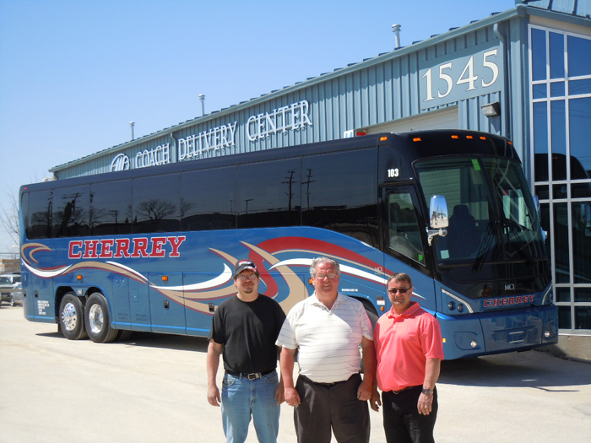
Allan Cherrey, second-generation owner and president of the Listowel, Ontario, company, waited in part because he wanted a J4500 with a Detroit Diesel engine. The coach's redesign inspired him to act as well. "I wanted the new look," said Cherrey, who said he was also attracted by the coach's more sophisticated ACTIA multiplexing and other new features.
Though the new J4500 has only been in Cherrey's fleet for about a month, he's already noticed the fuel economy gains that come with MCI's optimized powertrain. "The coach is doing a great job. On the ride home from the factory, it was getting 9 mpg imperial. It's not fully broken in yet, and we expect it to get even better."
He says he also noticed the new coach's improved ride and handling on the hilly ride home to Listowel. "It didn't seem to have any sway, and there was more control, even with the coach empty."
Cherrey opted for an ECAS kneeling system as well as seatbelts and 110-volt outlets for passengers; the company additionally has installed its own Wi-Fi and satellite tracking system, something it puts on all of its coaches. The Cherrey fleet presently numbers 22 coaches, all MCIs, as well as other vehicles. The company purchased its first new MCI coach in 1976.
Cherrey Bus Lines got its start in 1946, when founder Alva Cherrey started a garage business and a year later started transporting children to school. Today, the company is known for its excellent customer service and dedication to driver safety, serving Southwest Ontario and beyond; it also owns Maxey Family Adventures, Maxey Travel and Robin Hood Tours.
An active member of several industry associations, Allan Cherrey is a past chairman of the Ontario Motor Coach Association, a director of the School Bus Association, and has been a member on provincial committees to develop standards for mechanics. In 2009, he earned the OMCA's lifetime achievement award. For more information on the company, visit cherreybuslines.com.
Bilbrey Tours stays the course with new MCI® J4500
SCHAUMBURG, IL — July 25, 2013 — Repeat business doesn't just drive Bilbrey Tours — it also informs the company's purchasing decisions. Case in point is the Abilene, Texas company's new MCI J4500, delivered July 22.
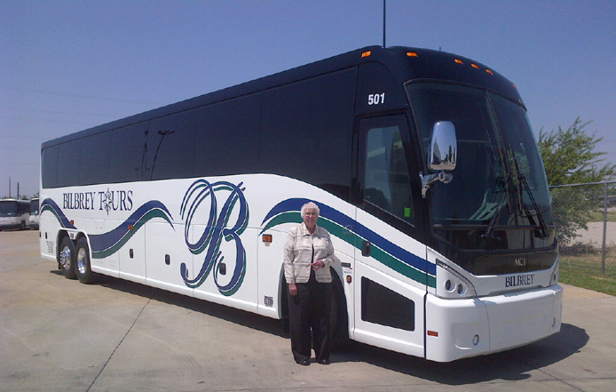
"We think the new coach is beautiful, and MCIs have always worked well for us," said Lena Bilbrey, president. "That's why we decided to stay with MCI."
The 2013 J4500 is one of two coaches in the Bilbrey fleet, joining an MCI E4500. The new J4500 has a clean-diesel Cummins engine, three-point seatbelts and a media hub for tour escorts, along with all the standard safety and performance features for which the best-selling model is known. The model underwent a redesign for 2013, gaining a taller look, distinctive angled headlights and technology advances including Actia multiplexing.
Having only two coaches allows Bilbrey Tours to lavish personal attention on its customers, about 80 percent of whom are repeat clients, according to Bilbrey. "This is what we can do well," says Bilbrey, who owns the company with her husband, Cleve. Her daughter, Rhonda, is also an integral part of the business, which
employs five people full time, plus eight additional part-timers. "We are very hands-on. We make a real effort to give our customers the best value and let them know how much they're appreciated. Our customers become our friends."
Now in its 24th year, Bilbrey Tours started as a home-based business, growing out of Lena Bilbrey's love of travel. The company moved into office space and bought its first coach in 1998.
Bilbrey Tours runs about 40 tours a year, mostly across the United States and Canada, but also to international and cruise destinations. Bilbrey says she has sent customers to all 50 states and 47 countries.
"We specialize in wholesome travel," said Bilbrey. "Whether it's a sporting event or a gospel concert or a quilt show, and whether it's a tour of two days or 15, we will have something to please everyone."
Including, she says, a shiny new coach.
Bilbrey Tours is a member of the National Tour Association, Cruise Lines International Association and the American Bus Association. For more information, visit bilbreytours.com.
Bloom's Bus Lines fleet blossoms with two new MCI® J4500 coaches
SCHAUMBURG, IL — August 12, 2013 — When it comes to coaches, Bloom's Bus Lines, Tauton, Massachusetts, knows the MCI J4500 model enhances its image. It's one of the reasons the tour and charter operator has been updating its fleet with the model over the past five years. "Our J4500s attract attention," said Gerry Santos, vice president and general manager. "We get callers telling us how good our coaches look going down the road."
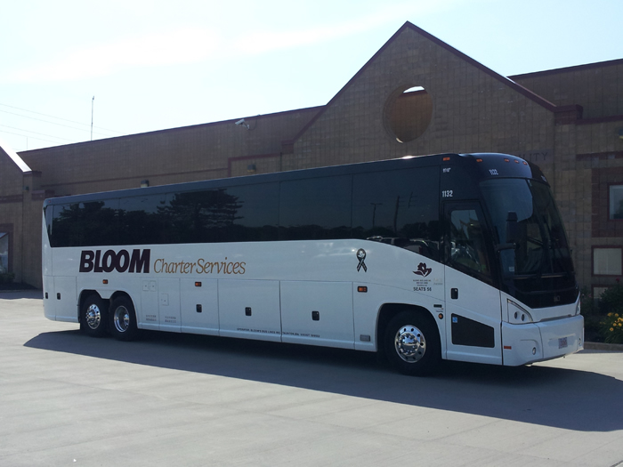
Calls are likely to increase because Bloom's two newest J4500 models, delivered last month, include a redesign with a more elevated presence; eye-catching, durable LED headlamps; and a smooth rear cap for even greater curb appeal. In addition, the model's standard safety features include electronic stability control; SmartWave® tire-pressure monitoring; fire detection and suppression;
Omnibus Society of America
PO Box A3051
Chicago IL 60690

and three-point passenger seatbelts. Bloom's Bus Lines added 110-volt outlets and Wi-Fi connectivity.
Besides the additional curb appeal, these newer models come with greater ecological benefits. Bloom's newest J4500s also feature EPA clean-diesel engine technology and powertrain enhancements for lower emissions and greater fuel efficiency. "We are finding better fuel economy on our newer models," said Santos, who also credits the company's 30-year career mechanic for keeping costs low through good fleet maintenance. Bloom's Bus Lines operates a 22-coach all-MCI coach fleet that includes 14 J4500 models. In all the company owns 200 vehicles including vans, sedans and school buses.
Located 40 miles south of Boston, Bloom's has many regular tour and charter customers and serves the well-known cruise ships operating out of Boston and Newport, Rhode Island, with trips to famous mansions

and area wineries. It also has contracts with college athletic teams and has been providing regular commuter route service between the Taunton area and Boston since 1979.
Bloom Bus consists of two companies, H & L Bloom, Inc. and Bloom's Bus Lines, Inc. H & L Bloom, established in 1946 by Harry and Lillian Bloom, provides school bus transportation to Taunton and the surrounding communities. Today, Mark Bloom, president and the founders' son, is leading both companies, while his son Matthew is dedicated to the school bus business.
Bloom's is an active member of New England Bus Association and Massachusetts Bus Association where Santos is a board member. Learn more at www.bloombus.com.

